**Kif6 P293T Genotyping**

Trying to re-create the human KIF6 P296T mutation reported to cause “dopa responsive dystonia and epilepsy”

CRISPR Target GGTCATCATGGAATTGCGGTAGG

Fish generated by BRT

Donor Sequence: changes 6nt and adds an EcoRI site (EcoRI should only cut mutant)

Primers:

Dr_kif6_P293T_fwd5 gctacgtttccagaatgagctt

Dr_kif6_P293T_revBT TGTACACCGATGTTCTTCTTCTC

***There is another EcoRI site nearby, if rev primer is moved further out genotyping won’t work***

**UCSC In-Silico PCR**

|  |
| --- |
|  |
|  | >[chr17:48698543-48698792](https://genome.ucsc.edu/cgi-bin/hgTracks?hgsid=612247783_UGZN8ZKeBNbcnZ3ZV49xsscoQu7H&db=danRer10&position=chr17:48698543-48698792&hgPcrResult=pack) 250bp GCTACGTTTCCAGAATGAGCTT TGTACACCGATGTTCTTCTTCTC  GCTACGTTTCCAGAATGAGCTTgggttgataatttgacatgaactacttt  cagcagaactgtgaaaacatcattttgtaaactgtttgtttcctggttta  ggtcatcatagccctgtcagagaaggataggtctcacatcccctaccgca  attccatgatgacctctgtactcagagacagtttgggcggtaactgcatg  accaccatgattgctactgtatccgtgGAGAAGAAGAACATCGGTGTACA |

PCR:

12.5ul GoTaq MM, 3ul primer mix, 5ul DNA, 4.5ul water

Tested with 55 anneal program (57 may be cleaner).

Digest with EcoRI. 5ul PCR product, 1.5ul CutSmart, 0.5ul EcoRI, 8ul water. 37C for 1 hour.

Run on a 2-4% gel

#1 and #3 have insert

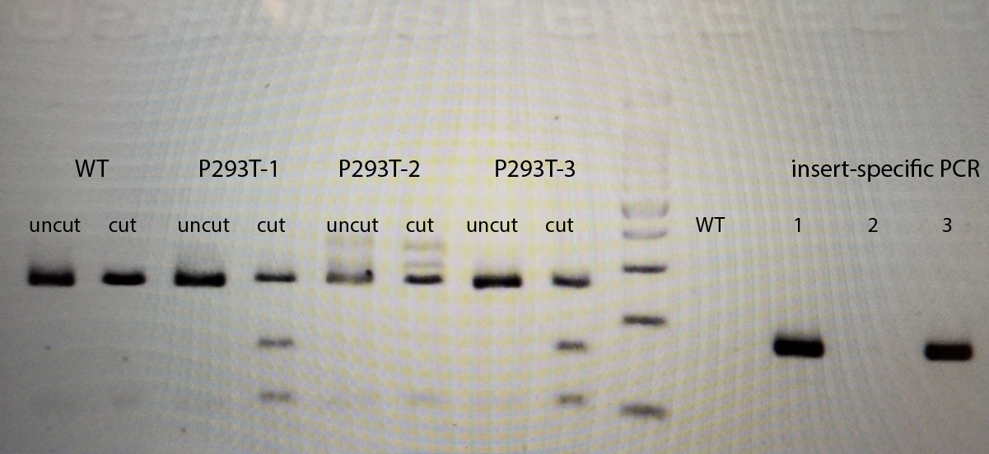

**Insert-specific PCR:**

Mutant allele uses these primers:

Dr_kif6_P293T_fwd5 gctacgtttccagaatgagctt

kif6_P293T_rev agaggtcatcatTgaattCcTAtaCgT

Test for WT allele uses these primers:

Dr_kif6_P293T_fwd5 gctacgtttccagaatgagctt

kif6_WT_293_rev tcatcatggaattgcggtaGGG

12.5ul GoTaq MM, 3ul primer mix, 5ul DNA, 4.5ul water

Tested with 55 anneal program

Sequence data from S212-4 Kif6 P293T F1 heterozygote:

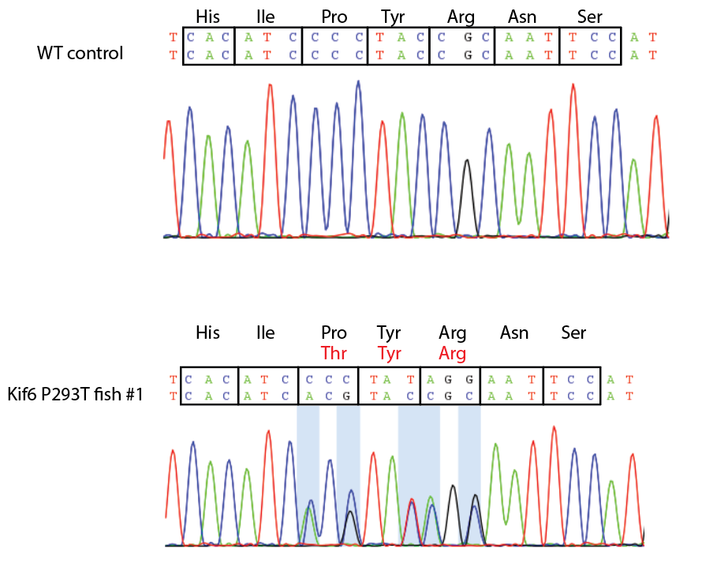

WT - GTCTCACATCCCCTACCGCAATTCCATGATGACCT

Mutant - GTCTCACATCaCgTAtaGgAATTCaATGATGACCT

Lowercase nt have been changed